
Why Some are Rich and Others Poor
Posted on February 1, 2025 by jamesq
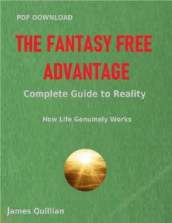
Fairness is not a natural part of our universe. Our species is born with a sense of fairness between ourselves and others, mostly on an individual basis. In society overall, self interest is our only significant incentive. The rich know how to succeed financially. The poor lack that skill.
Those of us who think in the light of reality know these things automatically. This amounts to possessing an advantage – The Fantasy Free Advantage. What is true is true…. whether we like it or not. Society as a whole fantasizes to avoid reality because in its raw form it is so daunting. Laws of dominance and subservience govern our world, Fantasy is a more pleasant notion and it replaces the gravity of our entire existence.
Notice that Jesus never tried to challenge the overall scheme of things in the world at that time. Instead, while being charitable to the poor, he never suggested a means of eliminating poverty. Sometimes what is not written in the bible is as important as what is clearly stated.
Accept reality as nature presents itself , and peace magically follows as disappointment wanes. Even if we can’t eliminate poverty, we have peace. Peace is worth a lot.

